**Android Linear Layout**

*Android LinearLayout is a view group that aligns all children in either vertically or horizontally.*

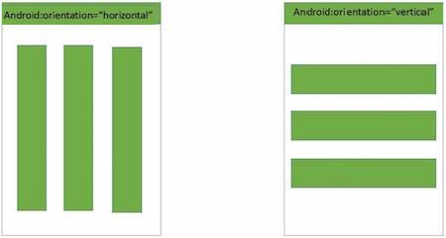

Linear Layout

LinearLayout Attributes

Following are the important attributes specific to LinearLayout −

|  |  |
| --- | --- |
| **Sr.No** | **Attribute & Description** |
| 1 | **android:id**  This is the ID which uniquely identifies the layout. |
| 2 | **android:baselineAligned**  This must be a boolean value, either "true" or "false" and prevents the layout from aligning its children's baselines. |
| 3 | **android:baselineAlignedChildIndex**  When a linear layout is part of another layout that is baseline aligned, it can specify which of its children to baseline align. |
| 4 | **android:divider**  This is drawable to use as a vertical divider between buttons. You use a color value, in the form of "#rgb", "#argb", "#rrggbb", or "#aarrggbb". |
| 5 | **android:gravity**  This specifies how an object should position its content, on both the X and Y axes. Possible values are top, bottom, left, right, center, center_vertical, center_horizontal etc. |
| 6 | **android:orientation**  This specifies the direction of arrangement and you will use "horizontal" for a row, "vertical" for a column. The default is horizontal. |
| 7 | **android:weightSum**  Sum up of child weight |

Example

This example will take you through simple steps to show how to create your own Android application using Linear Layout. Follow the following steps to modify the Android application we created in *Hello World Example* chapter −

|  |  |
| --- | --- |
| **Step** | **Description** |
| 1 | You will use Android Studio to create an Android application and name it as *Demo* under a package *com.example.demo* as explained in the *Hello World Example* chapter. |
| 2 | Modify the default content of *res/layout/activity_main.xml* file to include few buttons in linear layout. |
| 3 | No need to change string Constants.Android studio takes care of default strings |
| 4 | Run the application to launch Android emulator and verify the result of the changes done in the application. |

Following is the content of the modified main activity file **src/com.example.demo/MainActivity.java**. This file can include each of the fundamental lifecycle methods.

package com.example.demo;

import android.os.Bundle;

import android.app.Activity;

public class MainActivity extends Activity {

@Override

protected void onCreate(Bundle savedInstanceState) {

super.onCreate(savedInstanceState);

setContentView(R.layout.activity_main);

}

}

Following will be the content of **res/layout/activity_main.xml** file −

<?xml version="1.0" encoding="utf-8"?>

<LinearLayout xmlns:android="http://schemas.android.com/apk/res/android"

android:layout_width="fill_parent"

android:layout_height="fill_parent"

android:orientation="vertical" >

<Button android:id="@+id/btnStartService"

android:layout_width="270dp"

android:layout_height="wrap_content"

android:text="start_service"/>

<Button android:id="@+id/btnPauseService"

android:layout_width="270dp"

android:layout_height="wrap_content"

android:text="pause_service"/>

<Button android:id="@+id/btnStopService"

android:layout_width="270dp"

android:layout_height="wrap_content"

android:text="stop_service"/>

</LinearLayout>

Following will be the content of **res/values/strings.xml** to define two new constants −

<?xml version="1.0" encoding="utf-8"?>

<resources>

<string name="app_name">HelloWorld</string>

<string name="action_settings">Settings</string>

</resources>

Let's try to run our modified **Hello World!** application we just modified. I assume you had created your **AVD** while doing environment setup. To run the app from Android studio, open one of your project's activity files and click RunEclipse Run Iconicon from the toolbar. Android studio installs the app on your AVD and starts it and if everything is fine with your setup and application, it will display following Emulator window −

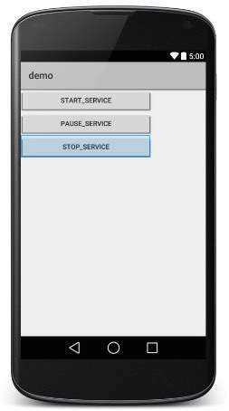

Now let's change the orientation of Layout as **android:orientation="horizontal"** and try to run the same application, it will give following screen −

